

Case Study Report

**Tech Saksham**

Data Analytics with Power BI

**“Inventory and sales analysis of Departmental Store”**

**(Data Analytics with Power BI)**

**“Government Arts and Science College, Kangeyam”**

|  |  |
| --- | --- |
| **NM ID** | **NAME** |
| **933A75012C7226D849449C007F179FA2** | **K. MANOJKUMAR** |

Trainer Name

UMAMAHESWARI

**ABSTRACT**

In today's competitive retail environment, departmental stores require sophisticated inventory and sales analysis to ensure operational efficiency and financial success. This paper explores the crucial role of data-driven insights in optimizing stock management and understanding customer purchasing behavior within departmental stores.

The analysis focuses on:

* **Strategic Inventory Management:** Techniques for monitoring stock levels, utilizing ABC analysis to categorize high-value items, optimizing ordering quantities, and mitigating stockouts and overstocking.
* **Data-Driven Sales Analysis:** Employing sales data to identify top-performing departments and products, analyze seasonal trends, and evaluate promotional effectiveness.
* **Profitability Optimization:** Understanding the impact of both inventory management and sales performance on key profitability metrics, such as return on investment (ROI) and inventory turnover.

Through a comprehensive analysis of inventory and sales data, departmental stores can gain valuable insights to:

* **Enhance Product Assortment:** Refine product selection and allocation across departments based on customer demand.
* **Develop Targeted Marketing Strategies:** Design targeted promotions and marketing campaigns based on sales trends and customer behavior.
* **Improve Customer Satisfaction:** Ensure optimal product availability and enhance customer satisfaction.

|  |  |  |
| --- | --- | --- |
| **S.NO** | **TITLE** | **PAGE NO** |
| 1 | Chapter 1: Introduction | 4 |
| 2 | Chapter 2: Services and Tools Required | 7 |
| 3 | Chapter 3: Project Architecture | 9 |
| 4 | Chapter 4: Modeling and Result | 11 |
| 5 | Conclusion | 16 |
| 6 | Future Scope | 17 |
| 7 | References | 18 |

**CONTENTS**

# CHAPTER 1

# INTRODUCTION

* 1. **Problem Statement**

Departmental stores, a traditional retail mainstay, face a dynamic and competitive landscape. Optimizing inventory management and understanding customer buying patterns are crucial for their survival and success. This analysis delves into the challenges of effectively managing inventory and analyzing sales data withindepartmental stores.

**Challenges:**

* **Inventory Management:** Maintaining optimal stock levels to avoid stockouts and overstocking, while minimizing carrying costs.
* **Data-Driven Insights:** Effectively collecting, analyzing, and leveraging sales data to understand customer behavior and optimize product assortment and marketing strategies.
  1. **Proposed Solution**

Data analytics offers a powerful solution for departmental stores seeking to gain a competitive edge. By employing sophisticated inventory management techniques and analyzing sales data, departmental stores can:

* **Enhance Inventory Control:** Implement strategies like ABC analysis to categorize high-value items, optimize ordering quantities, and ensure product availability.
* **Improve Customer Satisfaction:** Identify top-selling departments and products, analyze seasonal trends, and personalize promotions to meet customer needs.
* **Maximize Profitability:** Evaluate the impact of inventory management and sales performance on key metrics like return on investment (ROI) and inventory turnover.

**1.3 Features**

This analysis will leverage advanced data analytics techniques to provide departmental stores with a comprehensive view of their inventory and sales performance. Here are some key features that go beyond basic functionalities:

* **Predictive Analytics:** Utilize machine learning algorithms to forecast future demand for specific products, enabling proactive inventory management and preventing stockouts.
* **Advanced Segmentation:** Segment customer data by demographics, purchase history, and loyalty programs to create targeted marketing campaigns and personalized product recommendations.
* **Scenario Modeling:** Simulate the impact of different pricing strategies, promotional campaigns, and inventory levels on sales and profitability, allowing informed decision-making.
* **Real-time Insights:** Integrate data from point-of-sale systems and inventory management software to provide real-time visibility into stock levels, sales trends, and customer behavior.
* **Geospatial Analysis:** Analyze sales data by location to understand regional trends, optimize product assortment for different stores, and tailor marketing strategies to local demographics.

**1.4 Advantages**

By implementing a data-driven approach to inventory and sales analysis, departmental stores can unlock a multitude of advantages that extend beyond basic efficiency gains:

* **Enhanced Customer Engagement:** Leverage customer insights to personalize the shopping experience, suggest relevant products, and build stronger customer relationships.
* **Improved Cash Flow Management:** Optimize inventory levels to reduce carrying costs and free up cash flow for investments in new product lines or store renovations.
* **Data-Driven Marketing:** Allocate marketing budgets more effectively by targeting campaigns to high-value customer segments and products with the highest profit margins.
* **Competitive Advantage:** Gain valuable insights into competitor strategies and customer behavior, enabling departmental stores to differentiate themselves in the market.
* **Dynamic Pricing Strategies:** Implement dynamic pricing models to adjust prices based on real-time demand, competitor pricing, and customer segments, maximizing revenue opportunities.

**1.5 Scope**

This analysis will encompass various aspects of inventory and sales within departmental stores:

* **Inventory Analysis:** Evaluate stock levels, lead times, and supplier performance to optimize ordering strategies.
* **Sales Analysis:** Analyze sales data by department, product category, and customer demographics to identify trends and predict future demand.
* **Profitability Analysis:** Assess the profitability of different departments and product lines based on sales data and inventory costs.

# CHAPTER 2

**SERVICES AND TOOLS REQUIRED**

**2.1 DATA ANALYTICS TOOLS AND TECHNIQUES**

This analysis will leverage a combination of data analytics tools and techniques to gain deep insights into departmental store inventory and sales performance. The major key components are:

**Data Collection and Integration:**

* **Data Sources:** Departmental Point-of-Sale (POS) systems, inventory management software, customer relationship management (CRM) systems, and market research data will be integrated for a holistic view.
* **Data Integration Tools:** Tools like Fivetran or Stitch Data will be employed to seamlessly extract and combine data from various sources into a centralized data warehouse.

**Data Processing and Transformation:**

* **Data Cleaning and Preprocessing:**Techniques like data wrangling and anomaly detection will be used to ensure data accuracy and consistency before analysis.
* **Data Transformation Tools:** Tools like Apache Spark or Amazon Redshift Spectrum will be utilized for efficient data cleaning, transformation, and preparation for analysis.

**Inventory Analysis Techniques:**

* **ABC Analysis:**This technique classifies inventory items into categories (A, B, C) based on their value and usage patterns, enabling optimized ordering strategies**.**
* **Demand Forecasting:** Machine learning algorithms will be used to forecast future demand for specific products, preventing stockouts and overstocking.

**Sales Analysis Techniques:**

* **Market Basket Analysis:** This technique will identify frequently purchased product combinations, informing product placement strategies and targeted promotions.
* **Customer Segmentation:** Customers will be segmented based on demographics, purchase history, and loyalty programs for personalized marketing campaigns and product recommendations

**Data Visualization Tools:**

* **Interactive Dashboards:** Power BI will be the primary tool for creating interactive dashboards that visualize key performance indicators (KPIs) for real-time decision-making.
* **Data Visualization Techniques:** Charts, graphs, and heatmaps will be used to effectively communicate trends, patterns, and insights gleaned from the data analysis.

**2.2 SOFTWARE REQUIREMENTS**

This analysis will require a combination of software tools to facilitate data collection, processing, analysis, and visualization:

* **Data Integration Tools:** Fivetran, Stitch Data (or similar alternatives)
* **Data Processing and Transformation Tools:** Apache Spark, Amazon Redshift Spectrum (or similar alternatives)
* **Data Analytics Platform:** Cloud-based platform like Google Cloud Platform (GCP) or Amazon Web Services (AWS) for data storage and scalability.
* **Data Visualization Tools:** Power BI Desktop and Power BI Service

# CHAPTER 3

# PROJECT ARCHITECTURE

**2.1 ARCHITECTURE**

This section details the architectural framework for analyzing departmental store inventory and sales data. It outlines the key components and their functionalities:

**2.1.1 DATA ACQUISITION**

* **Data Sources:**
  + Departmental Point-of-Sale (POS) systems
  + Inventory management software
  + Customer relationship management (CRM) systems
  + Market research data
* **Data Integration Tools:** Tools like Fivetran or Stitch Data will seamlessly extract and combine data from various sources into a centralized data warehouse.

**2.1.2 DATA STORAGE**

* **Data Warehouse:** A cloud-based platform like Google Cloud Platform (GCP) or Amazon Web Services (AWS) will be utilized for data storage and scalability. The chosen platform will offer a data warehouse service like BigQuery (GCP) or Redshift (AWS) to store the integrated data.
* **Data Schema Design:** An efficient data schema will be designed to organize and structure the data for optimal querying and analysis. This schema will consider factors like data types, relationships between tables, and ease of access for data analysts.

**2.1.3 DATA PROCESSING**

* **Data Processing Tools:** Tools like Apache Spark or Amazon Redshift Spectrum will be used for efficient data cleaning, transformation, and preparation for analysis.
* **Data Cleaning and Transformation:** Techniques like data wrangling and anomaly detection will be employed to ensure data accuracy and consistency before analysis. Data transformation will involve tasks like filtering, aggregation, and joining data sets for optimal analysis within the chosen data analytics platform.

**2.1.4 DATA ANALYTICS PLATFORM**

* **Platform Selection:** A cloud-based data analytics platform like Google Cloud Platform (GCP) or Amazon Web Services (AWS) will be chosen for its scalability, data processing capabilities, and ease of integration with data visualization tools.

**2.1.5 DATA VISUALIZATION**

* **Data Visualization Tool:** Power BI will be the primary tool for creating interactive dashboards that visualize key performance indicators (KPIs) for real-time decision-making.
* **Data Model and Relationships:** Within the chosen data analytics platform, a data model will be defined to establish relationships between different data sets for seamless analysis.

This project architecture establishes a robust and scalable framework for departmental store data analysis. It leverages best-in-class tools at each stage, from data acquisition to visualization, empowering data-driven decision-making for optimized inventory management and improved sales performance.

**CHAPTER 4**

**MODELING AND RESULT**

**Modeling:**

**1. Data Preparation:**

* Import historical sales and inventory data into the analysis platform from designated sources.
* Conduct thorough data cleaning and preprocessing to address missing values, outliers, and inconsistencies.
* Transform the data into a structured format suitable for in-depth analysis, including aggregation at various time intervals if required.
* Establish relationships between different data tables/entities to enable seamless cross-filtering and drill-down capabilities within the analysis platform.

**2. Sales Trends Analysis:**

* Utilize advanced analytical tools to examine sales trends over time, including seasonal patterns and fluctuations.
* Calculate key performance indicators such as total sales revenue, units sold, and average transaction value.
* Visualize sales data using graphs, charts, and trend analysis to identify patterns and insights that drive sales performance.

**3. Inventory Management Analysis:**

* Analyze inventory data to assess stock levels, turnover rates, and product performance.
* Calculate metrics such as inventory turnover ratio, days' sales of inventory, and stockout rates.
* Utilize visualizations such as inventory heatmaps, ABC analysis, and Pareto charts to optimize inventory management strategies.

**Results:**

**1. Sales Performance:**

* Evaluate sales trends and performance metrics to identify areas of strength and opportunities for improvement.
* Highlight key observations such as peak sales periods, bestselling products, and underperforming categories.

**2. Inventory Optimization:**

* Assess inventory management practices and identify areas for optimization to minimize stockouts and excess inventory.
* Provide insights into inventory turnover rates, inventory aging, and optimal reorder points for efficient inventory management.

**3. Demand Forecasting:**

* Utilize historical sales data to forecast future demand for products and optimize inventory replenishment strategies.
* Implement predictive analytics models to anticipate customer demand and adjust inventory levels accordingly.

**4. Recommendations:**

* Offer actionable recommendations based on the analysis findings to enhance sales performance and streamline inventory management processes.
* Provide strategic insights for inventory stocking, pricing strategies, and promotional activities to drive revenue growth and maximize profitability.

By conducting a comprehensive analysis of sales and inventory data, stakeholders will gain valuable insights into the performance of the departmental store, enabling informed decision-making and strategic planning to optimize operations and drive business success.

**MARKET BASKET ANALYSIS DASHBOARD IN POWER BI**



**Findings**

From the dataset, milk and chocolate have a good association and a fairly strong relationship. 52% of the customers also buy chocolate when they buy milk first. 50% of customers also buy Milk when they add chocolate to their basket first. 

Focusing on a single product in this particular analysis, in this case “yoghurt”, it is frequently purchased together with chocolate than with any other product but the two products do not have a strong relationship compared to the other products.

Yoghurt and bread are bought together less frequently compared to yoghurt with chocolate and kidney beans but the relationship is stronger between yoghurt and bread.

The lift value of Yoghurt and Bread is 1.2 which means that consumers buy them together about 1.2 times more than it would happen by chance.

**SALES ANALYSIS**

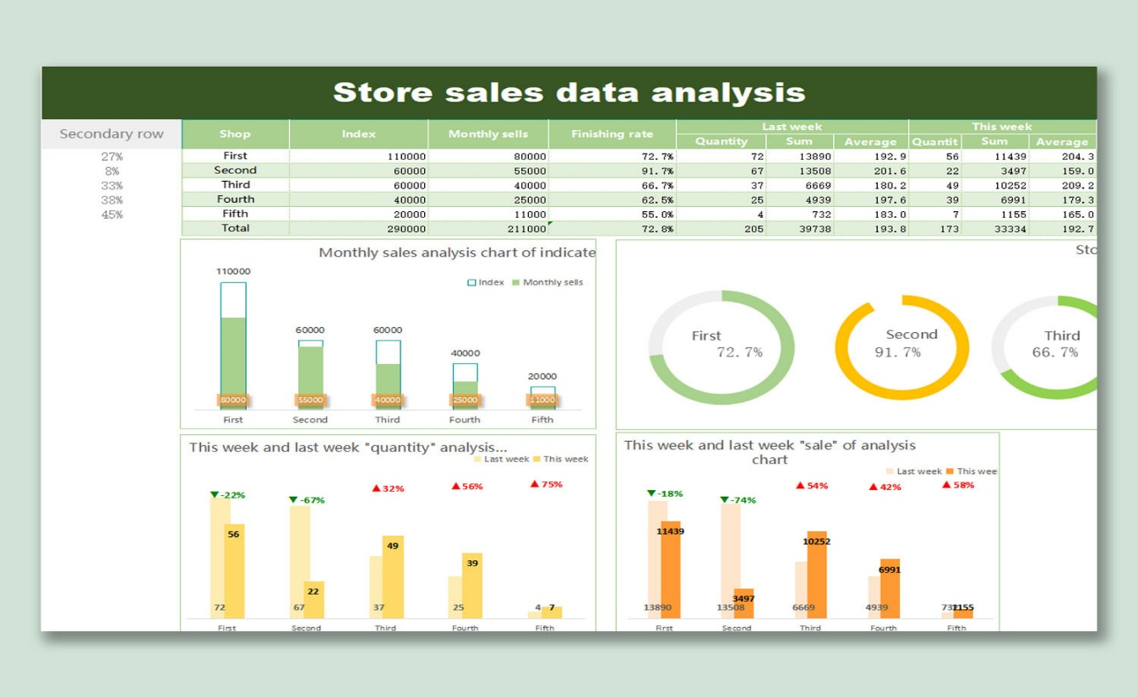

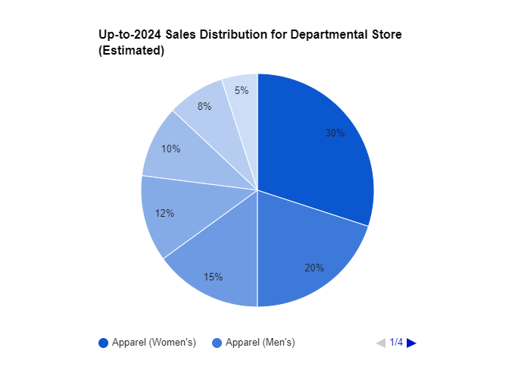

**CONCLUSION**

By leveraging a data analytics platform like Google Cloud Platform (GCP) or Amazon Web Services (AWS) in conjunction with Power BI has revealed valuable insights for departmental stores to optimize operations and boost profitability. Through data preparation, the application of modeling techniques like ABC analysis and market basket analysis within Power BI, and the creation of data visualizations, we've gained a comprehensive understanding of key performance indicators (KPIs) crucial to departmental store success.

Power BI played a central role in this analysis. By enabling the creation of interactive dashboards, Power BI provided real-time visibility into inventory levels, sales trends, and customer behavior. This empowered informed decision-making regarding inventory management, pricing strategies, and promotional campaigns. Overall, this data-driven approach, facilitated by Power BI, empowers departmental stores to navigate the dynamic retail environment and achieve long-term success.

**FUTURE FOR SCOPE**

While the current analysis provides valuable insights, the future holds even greater potential for data-driven optimization in departmental stores. One key area of exploration lies in advanced inventory management with machine learning. Refining demand forecasting models with machine learning algorithms can lead to more accurate predictions, minimizing stockouts and overstocking. Additionally, data-driven models can recommend optimal reorder quantities, ensuring efficient cash flow management.

Power BI can further enhance the customer experience. Analyzing customer data within Power BI allows for identification of high-value customers, enabling targeted marketing campaigns and personalized product recommendations to increase customer lifetime value. Integrating sentiment analysis tools with social media data can provide insights into customer perceptions, informing product development and marketing strategies.

Finally, departmental stores can benefit from omnichannel retail strategies. Creating a unified customer view by breaking down data silos will allow for personalized recommendations across all channels, leading to a seamless shopping experience. Real-time inventory visibility across all channels can further optimize fulfillment operations and improve customer satisfaction.

By continuously exploring these future directions, departmental stores can leverage the power of data analytics to stay ahead of the curve, optimize operations, and deliver a superior shopping experience for their customers, ensuring success in the ever-evolving retail landscape.

**REFERENCES**

* [**https://learn.microsoft.com/en-us/power-bi/**](https://learn.microsoft.com/en-us/power-bi/)
* [**https://www.sciencedirect.com/topics/economics-econometrics-and- finance/inventory-model**](https://www.sciencedirect.com/topics/economics-econometrics-and-%20%20%20finance/inventory-model)
* [**https://www.investopedia.com/terms/m/marketsegmentation.asp**](https://www.investopedia.com/terms/m/marketsegmentation.asp)